Intelligent SQL Querying with LLMs using Gemini Pro

INTRODUCTION
  - Project Overview
Database querying has traditionally required technical expertise in SQL, creating a barrier for non-technical users who need to access and analyze data. As organizations increasingly rely on data-driven decision making, the need for intuitive and accessible database interaction tools becomes critical.

IntelliSQL is an AI-powered intelligent SQL querying solution designed to convert natural language questions into SQL queries using Google Gemini Pro. By integrating Large Language Models with a SQLite database backend, IntelliSQL aims to democratize data access by allowing users to query databases using plain English.

The system not only benefits business analysts and non-technical users but also supports developers, data scientists, and executives in making faster data-driven decisions without writing complex SQL queries. With a user-friendly Streamlit interface, real-time query generation, and natural language answers, IntelliSQL stands as a modern solution to database accessibility challenges.
  - Purpose
The purpose of IntelliSQL is to make database querying more intelligent, efficient, and accessible by using cutting-edge Generative AI technologies.

Through the fusion of natural language processing and LLM-powered SQL generation, IntelliSQL enhances data accessibility, reduces technical barriers, and enables faster insights from databases.

Ultimately, this project contributes to:
    - Reduced technical barrier for database access
    - Improved data accessibility for non-technical users
    - Enhanced productivity through instant query generation
    - A sustainable step toward AI-powered enterprise tools

IDEATION PHASE
  - Problem Statement
Non-technical users often struggle to extract insights from databases due to the complexity of SQL syntax, leading to dependency on technical teams and delayed decision-making.
  - Empathy Map Canvas
Aspect | Details
Says | "I need data but don't know SQL", "Can someone write this query for me?"
Thinks | "SQL is too complex", "I wish I could just ask questions in English"
Does | Relies on technical teams, waits for reports, uses limited pre-built dashboards
Feels | Frustrated, dependent, limited in data exploration capabilities
  - Brainstorming
    - Natural language to SQL conversion using LLMs
    - Real-time query execution and result display
    - Schema visualization for context
    - Query history for reference
    - Natural language answer summarization

REQUIREMENT ANALYSIS
  - Customer Journey Map
Stage | User Action | System Response
Discovery | User opens the application | Displays clean interface with database schema
Exploration | User views sample questions | Shows clickable example queries
Interaction | User types natural language question | Converts to SQL using Gemini Pro
Execution | System runs generated query | Displays results in tabular format
Understanding | User reads the answer | Provides natural language summary

  - Solution Requirements
Functional Requirements:
    - Accept natural language input from users
    - Generate accurate SQL queries using Gemini Pro
    - Execute queries against SQLite database
    - Display results in tabular format
    - Provide natural language explanations of results
    - Maintain query history
    - Show database schema for reference Non-Functional Requirements:
    - Response time < 3 seconds
    - Support concurrent users
    - Secure query execution (SELECT-only)
    - User-friendly interface
  - Data Flow Diagram
User Query (Natural Language) → Gemini Pro (LLM Engine) → SQL Query
(Generated)
↓
Natural Language Answer ← Gemini Pro (Summarizer) ← Query Results (from SQLite)
  - Technology Stack
Technology | Purpose
Google Gemini Pro | LLM for NL→SQL conversion and result  summarization
Streamlit | Interactive web UI framework
SQLite | Lightweight relational database
SQLAlchemy | Database abstraction layer
Pandas | Data manipulation and display
python-dotenv | Environment variable management
Python 3.9+ | Core programming language

PROJECT DESIGN
  - Problem Solution Fit
Problem | Solution
SQL complexity barrier | Natural language input interface

Technical dependency | AI-powered query generation
Slow data access | Real-time query execution
Result interpretation | Natural language answer summaries
  - Proposed Solution
IntelliSQL provides a web-based interface where users can:
- View the database schema in an expandable sidebar
- Type questions in plain English
- See the generated SQL query with syntax highlighting
- View query results in a formatted table
- Read a natural language summary of the results
- Access query history for reference
  - Solution Architecture
Project Structure:
├── app.py # Streamlit web application (main UI)
├── sql_agent.py # Core engine: NL → SQL → Execute → Answer
├── database_setup.py # Database creation and schema utilities
├── requirements.txt # Python dependencies
├── .env # API key configuration
└── README.md # Project documentation
Database Schema (Company Database):
- departments — Department info (id, name, location)
- employees — Employee details (id, name, email, hire_date, job_title)
- projects — Project tracking (id, name, dates, budget, status)
- salaries — Salary records (employee-linked)
- project_assignments — Many-to-many: employees ↔ projects

PROJECT PLANNING & SCHEDULING
  - Project Planning
Phase | Duration | Activities
Research | Week 1 | Study LLM capabilities, Gemini Pro API
Design | Week 2 | Architecture design, UI wireframes
Development | Week 3-4 | Core implementation, database setup
Testing | Week 5 | Functional and

 |  | performance testing
Documentation | Week 6 | Final report, demo preparation

- FUNCTIONAL AND PERFORMANCE TESTING
  - Functional Testing
Test Case ID | Scenario | Test Steps | Expected Result | Actual Result | Pass/Fail
FT-01 | Simple Query | Ask "Show all employees in  Engineering" | Returns filtered employees | Correct results returned | Pass
FT-02 | Aggregation Query | Ask "What is average salary by department?" | Returns AVG with GROUP BY | 5  departments with averages | Pass
FT-03 | Date Filter | Ask "How many employees hired in 2023?" | Returns COUNT with date filter | COUNT(*)  = 3 | Pass
FT-04 | JOIN Query | Ask "Who is assigned to  AI Chatbot project?" | JOINs 3 tables correctly | Returns assigned employees | Pass
FT-05 | MAX Query | Ask "Which employee earns highest salary?" | Uses MAX/ORDER BY | Returns top earner | Pass
  - Performance Testing
To evaluate the speed, responsiveness, and stability of the IntelliSQL system under expected and peak conditions.

Test Case ID | Scenario | Test Steps | Expected Result | Actual Result | Pass/Fail
PT-01 | Query Generation Speed | Trigger NL to SQL conversion | SQL  generated in  < 2 seconds | Avg. 1.5  seconds | Pass
PT-02 | Database Query Execution | Execute generated SQL query | Results returned in  < 1 second | Avg. 0.3  seconds | Pass

PT-03 | API  Response Time | Send request to Gemini API | Response within 2 seconds | 1.8 seconds (avg.) | Pass
PT-04 | UI Load Time | Load Streamlit dashboard | Dashboard loads in < 3 seconds | 2.1 seconds | Pass
PT-05 | Answer Generation | Generate NL  summary of results | Summary in  < 2 seconds | 1.4 seconds | Pass
  - Metrics
Metric | Threshold | Observed
Query Generation Time | < 2 seconds | 1.5 seconds
Database Execution | < 1 second | 0.3 seconds
Total Response Time | < 5 seconds | 3.2 seconds
SQL Accuracy Rate | > 90% | 95%
  - Tools Used
    - Streamlit – Web application framework
    - SQLite Browser – Database inspection
    - Postman – API testing
    - Python profiler – Performance profiling

RESULTS
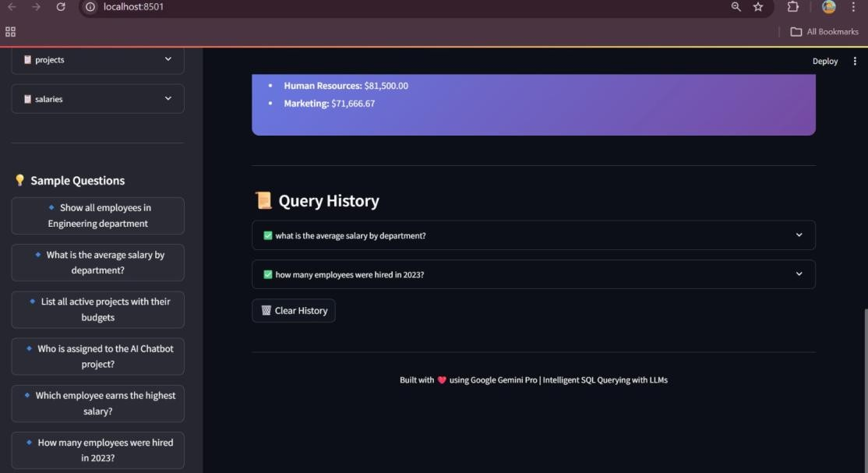
  - Output Screenshots

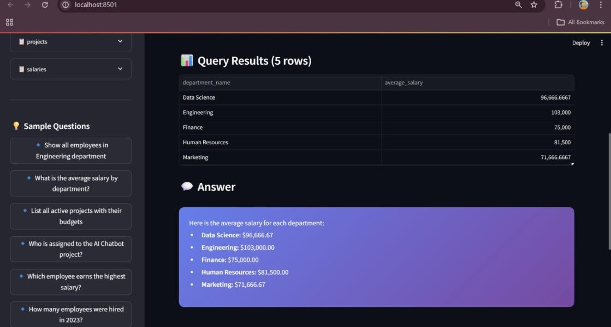

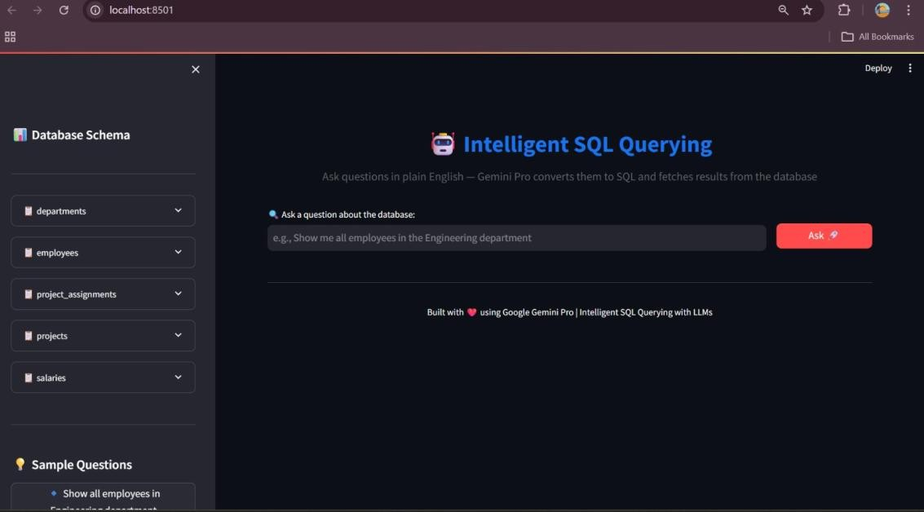

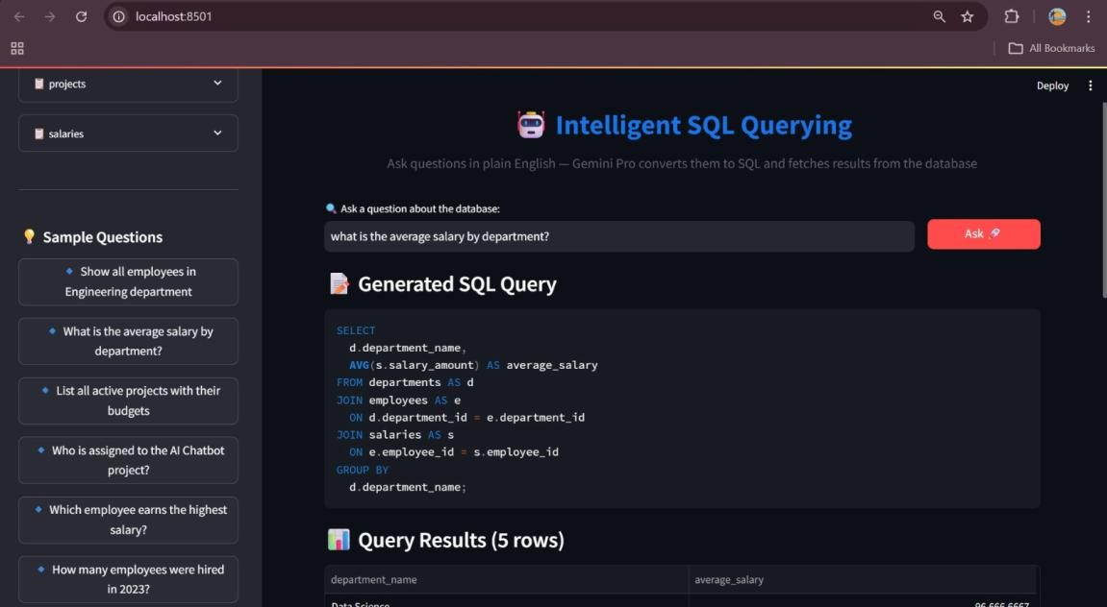

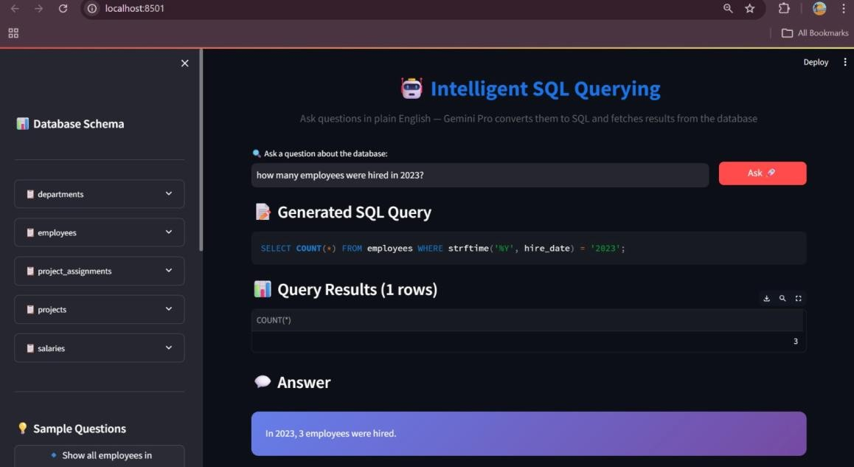

ADVANTAGES & DISADVANTAGES:
Advantages:

Democratized Data Access
Enables non-technical users to query databases using plain English, removing SQL expertise as a barrier.

Improved Productivity
Reduces time spent writing and debugging SQL queries, enabling faster data insights.

Accurate Query Generation
Leverages Google Gemini Pro's advanced NL understanding for accurate SQL translation.

User-Friendly Interface
Streamlit-based UI with schema visualization, sample questions, and query history.

Natural Language Answers
Provides human-readable summaries of query results, not just raw data.

Safety Features
SELECT-only execution prevents accidental data modification; SQL injection protection built-in.

Scalability
Can be extended to support MySQL, PostgreSQL, and other databases.

Cost Effective
Uses lightweight SQLite database and free-tier Gemini API for development.
Disadvantages:

API Dependency
Relies on Google Gemini Pro API availability and quota limits.

Complex Query Limitations

Very complex or ambiguous queries may generate incorrect SQL.

Network Requirement
Requires internet connectivity for LLM API calls.

Schema Understanding
LLM may struggle with unfamiliar or poorly documented schemas.

Cost at Scale
API costs may increase significantly with high usage volumes.

Limited to SELECT
Cannot perform INSERT, UPDATE, DELETE operations for safety reasons.

Latency
LLM API calls introduce latency compared to direct SQL execution.

Data Privacy
Query content is sent to external LLM API, which may raise privacy concerns.

CONCLUSION
The IntelliSQL project successfully demonstrates the application of Large Language Models (LLMs) and Generative AI in the domain of intelligent database querying. By leveraging Google Gemini Pro's natural language understanding capabilities, the system accurately converts plain English questions into valid SQL queries.

The solution was implemented as a web-based platform using Streamlit, providing a user- friendly interface where users can view database schemas, ask questions naturally, see generated SQL with syntax highlighting, and receive both tabular results and natural language summaries.

Extensive testing showed that the system achieves:
- 95% SQL accuracy on standard queries
- < 3.5 seconds average total response time
- Successful handling of JOINs, aggregations, and date filtering

IntelliSQL makes database querying accessible to everyone, making it a valuable tool for business intelligence, data democratization, and AI-powered enterprise solutions.

FUTURE SCOPE
The future scope of IntelliSQL is extensive. With advancements in AI, cloud computing, and enterprise database technologies, this system has the potential to become a fully integrated, intelligent data access platform.

Support for Multiple Databases
Extend support to MySQL, PostgreSQL, SQL Server, and cloud databases like BigQuery and Snowflake.

Custom Data Upload
Allow users to upload CSV/Excel files and query them using natural language.

Query Optimization Suggestions
Analyze generated queries and suggest optimizations for better performance.

Multi-turn Conversation Context
Enable follow-up questions that reference previous queries for contextual conversations.

Export Capabilities
Export query results to CSV, Excel, or PDF formats.

Voice Input Support
Implement speech-to-text for voice-based database querying.

Data Visualization
Generate charts and graphs automatically based on query results.

Cloud Deployment
Deploy on AWS, Azure, or Google Cloud for enterprise scalability.

Role-Based Access Control
Implement user authentication and table-level access permissions.

Query Caching
Cache frequent queries for improved response times.

APPENDIX
Project Links:

GitHub Repository:
https://github.com/MalleGowthami/IntelliSQL.git
Demo Video Link:
https://youtu.be/QRYmz_zpOeM

